## Exercise 04: Making a medical questionnaire (2) - field validation

* Adding a patient email address:

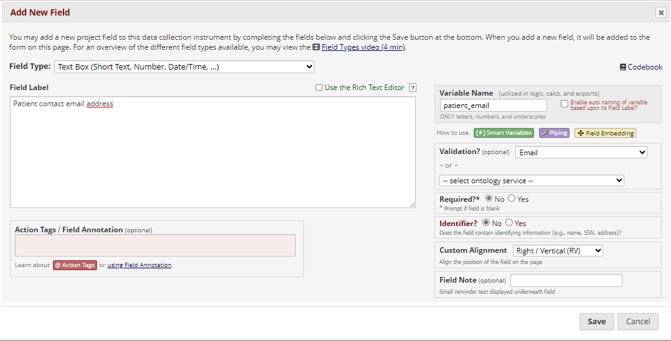

* Adding a field for the number of doctor visits in the last 12 months:

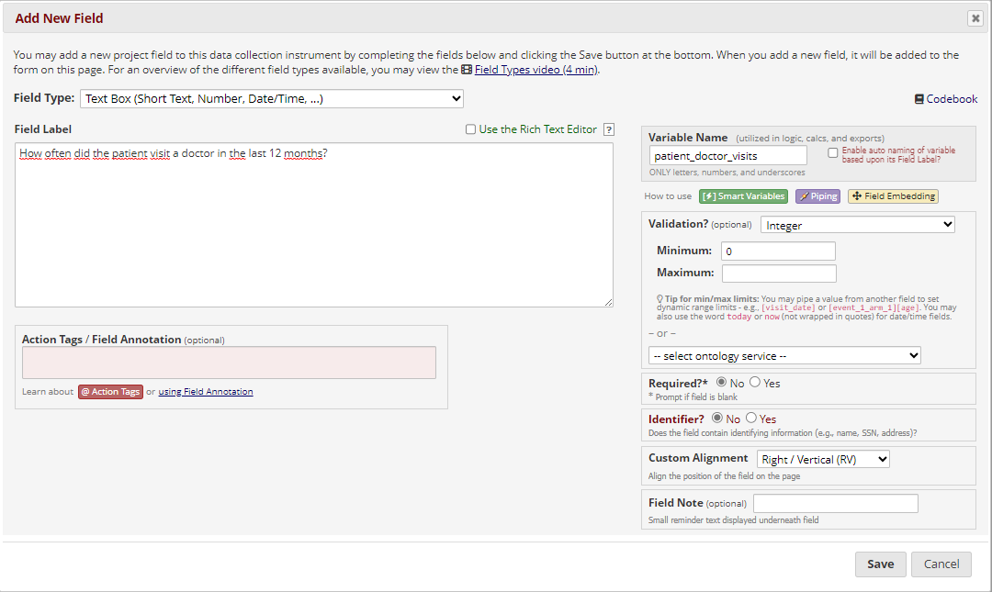

* Adding a patient’s birthdate:

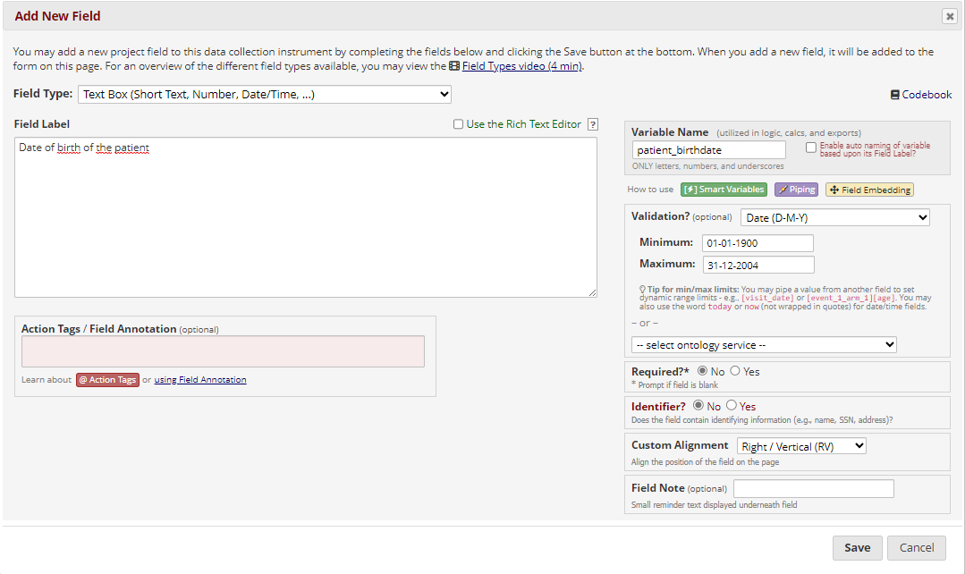

* Modify the “visit_date” field to validate the date, and add the minimum value:

